PROJECT 6
The Ghost in the Machine
Adversarial Fraud Detection

Protecting the Payment Gateway from Synthetic Identity

Industry: Digital Payments / Cybersecurity / AdTech
Duration: 2 Sprints (10 Working Days)
Format: MVP / Proof of Concept

Futurense AI Clinic
April 2026

THE FRAMEWORK

How Enterprise Teams Attack a Data Problem
Before you read the project-specific brief, understand the general sequence. Every enterprise ML engagement, whether at a bank, a logistics company, or a government agency, moves through the same fundamental stages. The details change. The rhythm does not.
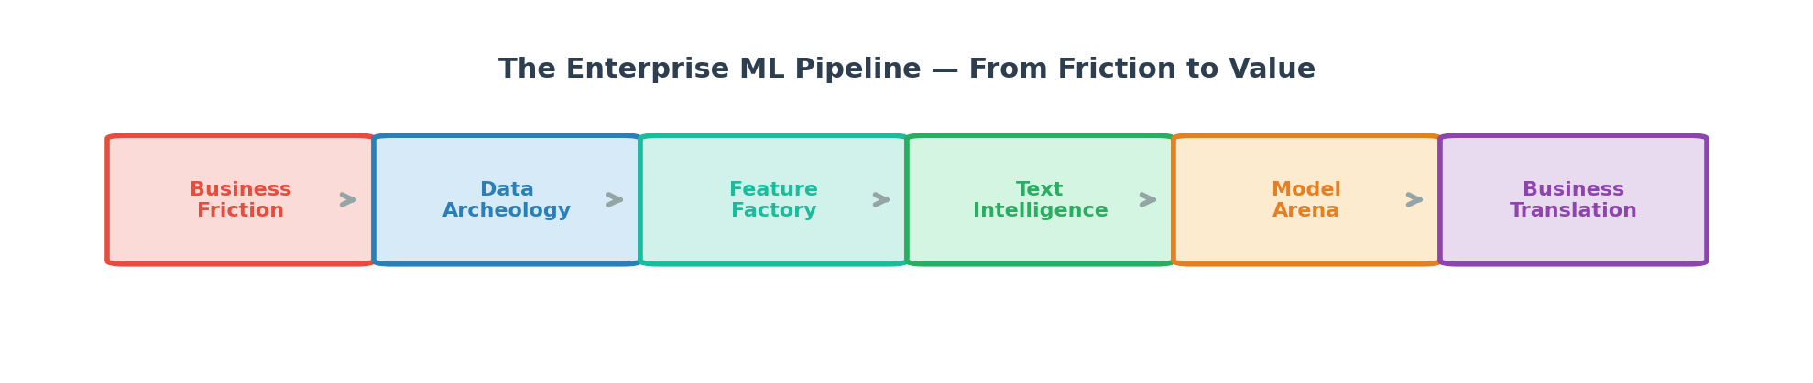
It starts with understanding the business friction: what is costing the organization money, time, or trust? Then comes data archeology: profiling, joining, cleaning, and understanding the mess you have been handed. The feature factory is where raw data becomes predictive signal. Text intelligence is where unstructured language gets quantified. The model arena is where hypotheses are tested. And the final stage, the one most teams skip and the one that separates juniors from seniors, is business translation: converting a statistical result into a recommendation that a non-technical stakeholder can act on.
In the real world, nobody gives you a clean CSV and a list of instructions. They give you a problem and a mess. Start with the mess.
THE SITUATION ROOM

The Business Friction
A payment processor is seeing a spike in chargebacks. Fraudsters are getting smarter. They no longer use stolen cards in obvious ways. They mimic real user behavior: normal purchase amounts, normal times of day, normal device fingerprints. By the time the fraud is confirmed, the money is gone.
The business constraint is counterintuitive: they would rather let some fraud through than block a legitimate customer's purchase. A false positive (blocking a real customer) costs more in lifetime value than a false negative (missing a fraudster). This means the model must optimize for precision, not recall. And the evaluation must explicitly account for the asymmetric cost of errors.
In fraud detection, the enemy adapts. A model that works today will be reverse-engineered by fraudsters tomorrow. The challenge is not just building a good model. It is building a model that degrades gracefully as adversaries evolve.

THE DATA YOU INHERIT

The Data Landscape
This dataset comes from the IEEE Computational Intelligence Society, released as a Kaggle competition by Vesta Corporation, a real payment processor. It contains two tables: a transaction table and an identity table, linked by TransactionID.
The transaction table has 394 columns. Many are anonymized: V1 through V339. You do not know what they represent. The identity table has device and network information, also partially anonymized. This is intentional. In real fraud detection, feature meaning is often obscured for security reasons.
The anonymization is the core challenge. You cannot apply domain knowledge to features you cannot name. You must discover structure from the data itself: through correlation analysis, null pattern analysis, and dimensionality reduction.
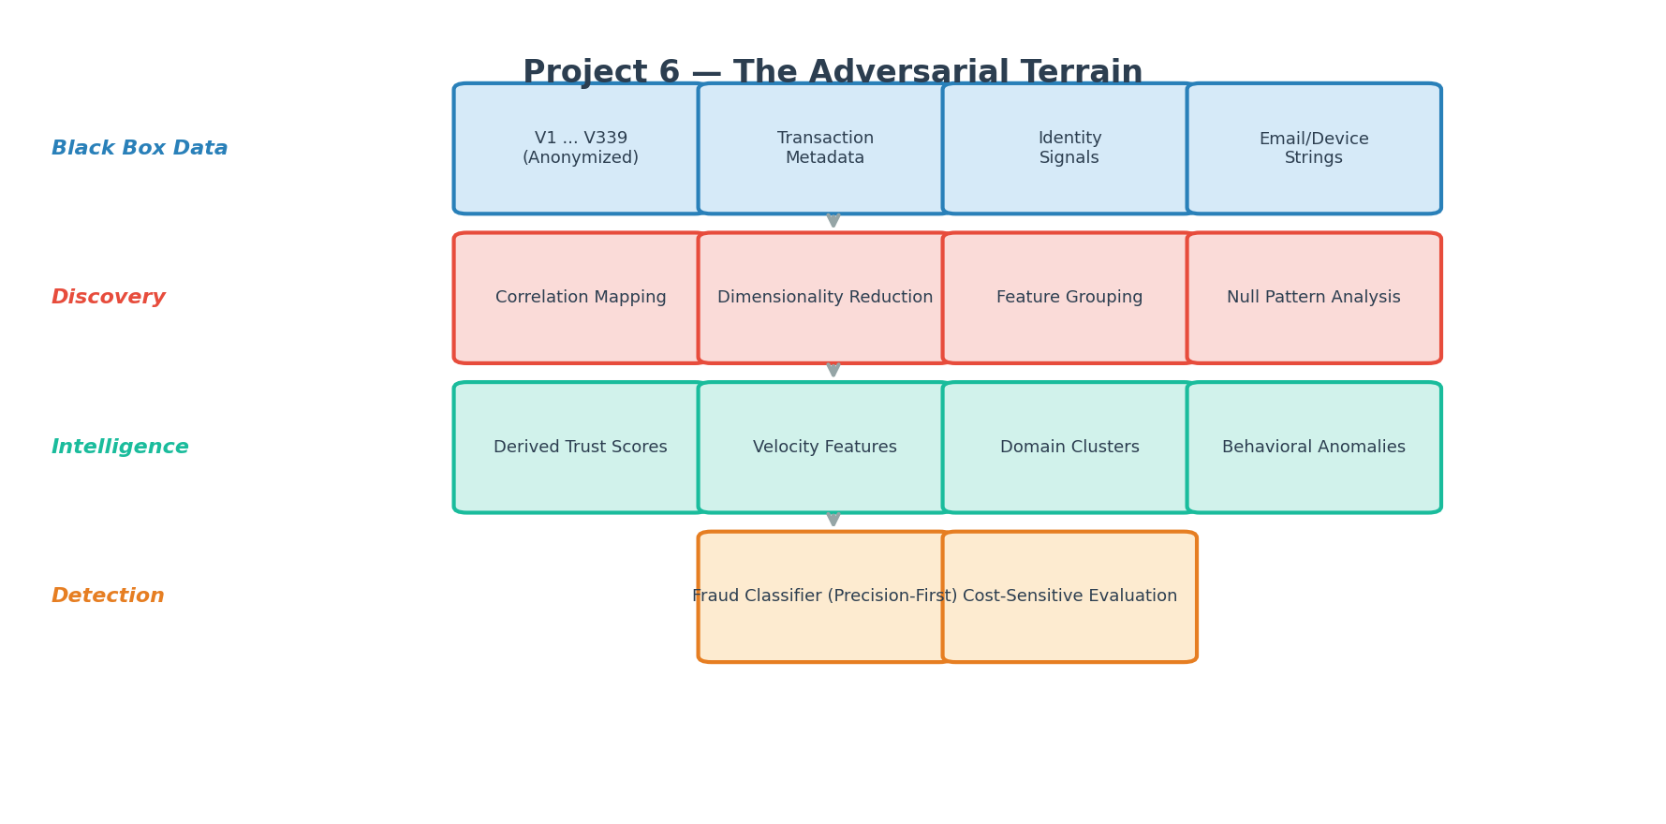
IEEE-CIS Fraud Detection Competition Data

THE INTELLECTUAL TERRAIN

What the Business Needs You to Think About

The Black Box Problem
You have 339 anonymized features. You cannot read their names and infer their meaning. You must let the data speak. Correlation matrices, null-pattern co-occurrence, and principal component analysis become your eyes. Some of the V-features are likely related (they came from the same source). Can you discover those groupings?
If you reduce 339 features to 30 principal components, you gain computational efficiency but lose interpretability. In fraud detection, regulators sometimes require that you can explain why a transaction was flagged. How do you balance dimensionality reduction with the need for explainability?

The Adversarial Reality
Fraud data is not stationary. The patterns you learn from historical data reflect yesterday's fraud tactics. Tomorrow's fraudsters will change behavior. A model that overfits to historical fraud patterns will miss novel attacks. Think about how robust your features are to behavioral drift.
Velocity features (how many transactions from this card in the last hour, how many different devices used this email in the last day) tend to be more robust to adversarial drift than static features. Why might that be?

Where Text Meets Structure
The email domain fields (P_emaildomain, R_emaildomain) and the DeviceInfo field are string columns embedded in a sea of numerical features. They are small, but they are rich. The difference between a gmail.com sender and an anonymous.com sender carries signal. The device string encodes information about operating system, browser, and hardware.
Can you derive a "trust score" from an email domain? What about a "device modernity score" from the device string? These are the kind of micro-NLP tasks that enterprise fraud teams build as feature enrichment layers.

The Cost-Sensitive Evaluation
Standard F1, AUC, and accuracy metrics treat false positives and false negatives equally. In this business context, they are not equal. Blocking a legitimate $500 purchase costs the business the customer relationship. Missing a fraudulent $500 purchase costs the business $500 plus chargeback fees.
How do you build an evaluation framework that reflects asymmetric costs? What if you assigned a dollar value to each type of error and optimized for total cost instead of a statistical metric? How would that change your threshold selection?

How This Gets Built in the Real World
Enterprise fraud detection systems are layered. The first layer is rule-based: hard blocks on known bad IPs, velocity limits, and blocklists. The second layer is model-based: scoring each transaction with a probability. The third layer is human review: transactions above a risk threshold but below a certainty threshold go to an analyst queue. Your project focuses on the second layer, but thinking about how it fits into the full system will make your solution more mature.
The best fraud models are not the most accurate. They are the ones that catch the most fraud while blocking the fewest real customers. Precision at high recall is the metric that matters, and the threshold where you set the cutoff is a business decision, not a statistical one.

OPERATING STANDARDS

The Operating Model
These standards apply regardless of which project you are working on. They are non-negotiable. In enterprise data science, the quality of your process is evaluated as rigorously as the quality of your model.

Engineering Hygiene: Git & GitHub
In industry, code that is not version-controlled does not exist. Your GitHub repository is not a submission folder. It is the living history of how your team thinks, collaborates, and iterates.
If your commit history shows one giant commit on the last day, you have demonstrated the opposite of professional engineering practice.
Consider what a senior engineer reviewing your repository would look for. They would look at branch naming conventions that reflect intent. They would look at commit messages that tell a story. They would look at pull requests that show peer review happened before code was merged. They would look at a README that lets a stranger set up and run your project in under five minutes.
Your repository structure should separate concerns: raw data stays untouched, processing code lives in modules, notebooks are for exploration and storytelling, and documentation explains decisions made along the way. Think about what belongs in .gitignore and why.

Operating Rhythm: Agile Practices
You are running a two-sprint engagement. Not because this is an academic exercise, but because every enterprise data science project operates in sprints.
Sprint 1 is your discovery and foundation phase. The business problem needs to be understood, the data needs to be profiled, the architecture needs to be sketched, and a baseline needs to prove the problem is tractable. Sprint 2 is where engineering maturity shows. Features get refined, text intelligence gets integrated, models get compared rigorously, and the solution gets translated back into business language.
Daily standups are not status reports. They are coordination mechanisms. Three questions, answered by each member, taking no more than two minutes each: What did I close? What am I picking up? What is in my way?
Track your work visibly. GitHub Issues and a Kanban board are the minimum. When a task moves from "In Progress" to "Done," there should be a commit, a review, and an updated document to prove it.

The Co-Pilot Protocol: AI & GenAI Tools
AI tools are permitted. They are not your replacement. They are your accelerator. The distinction matters.
The test is simple: if you cannot explain every line of code in your pipeline during a live walkthrough, the code is not yours, regardless of who or what wrote it.
Use AI to clarify concepts, debug errors, generate boilerplate, and refactor messy code. Document every significant AI interaction in a PROMPTS.md file in your repository. Log the tool, the prompt, and how you validated or modified the output. This is not bureaucracy. Companies like Google, Deloitte, and McKinsey now require AI usage documentation on internal projects.
Before you paste your dataset schema into any AI tool, ask yourself: if this were real client data, would you be comfortable sending it to a third-party API? Treat every dataset as company-confidential. Describe your schema; do not upload your data.
The strongest prompt engineers are specific. Instead of asking "help me with ML," they describe the shape of their data, the business constraint, and the specific technical decision they are stuck on. Iterate on your prompts. The first answer is generic. The third is gold.

Design Thinking: HLD & LLD
Enterprises do not start coding on Day 1. They design. Your team must produce two artifacts before any model training begins.
The High-Level Design is your architecture story. One to two pages. It answers: What is the business problem and who cares? Where does the data come from and how does it connect? What does the pipeline look like from raw files to predictions? What metric will you optimize, and why that one instead of another? What assumptions are you making, and what could break them?
The Low-Level Design is your engineering blueprint. It specifies: every feature you intend to use, its type, its source, and your strategy for missing values. It documents your text processing pipeline. It lists your model hypotheses and your evaluation strategy.
Both documents must exist in your repository under /docs before any modeling work begins. A team that skips design and jumps to code is a team that will rewrite everything in Week 2.

Stakeholder Communication: Presentations
The Weekend Checkpoint
This is not a polish exercise. It is a progress demonstration. Show what the data revealed during exploration. Show the data quality problems you discovered and the decisions you made. Show your architecture diagram. Show a baseline model and its honest metrics. Show what is blocking you and what your plan is for the second sprint.
The Final Presentation
Present as if you are in a room with the VP of Data Science at the company whose problem you are solving.
Start with the business context. Why does this problem cost money? Then tell the data story. What surprised you? What insight drove your feature engineering? Walk through your technical approach at a level where a technical manager can follow. Show results with proper evaluation, not just accuracy. Translate your best model into a business recommendation. End with a retrospective: what worked, what didn't, what you would do differently.
Every team member must speak. If one person presents everything, the team loses credibility. In enterprise consulting, this is disqualifying.

Working as a Team
The commit history is your evidence of collaboration. If one member has 90% of the commits, the team has a problem, not a star.
Divide by verticals, not by sequence. One person should not "do EDA" while others wait. Parallel work on data integration, text processing, and model architecture is how real teams operate. Pair programming accelerates learning and reduces bugs. Two people on the same problem produce better output than two people on separate problems.
When two people disagree on an approach, the resolution is not debate. It is experiment. Implement both, compare results, and let the data decide. Document the comparison in your notebook.
Hold each other accountable early. A blocker raised on Day 3 is manageable. A blocker revealed on Day 9 is a project failure.

Solution Maturity
Your work will be evaluated on the maturity of your approach, not just the accuracy of your model.
A student-level submission runs a model and reports a number. A practitioner-level submission includes proper exploration, documented decisions, and multiple model comparisons. An engineer-level submission has modular code, pipeline architecture, justified feature engineering, and meaningful NLP integration. A consultant-level submission translates model outputs into business recommendations, performs error analysis, identifies edge cases, and discusses deployment considerations.
Aim for engineer-level. Impress us with consultant-level.

